Practice Query - 2

- Find the highest salary of each department

select Departement, max(salary) from Employee group by Departement;
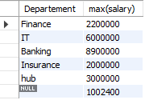
- Find the highest salary of each year on joining_date

select joining_date, max(salary) from Employee group by year(Joining_date);
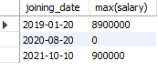
- Find the highest salary of each quarter on joining_date

select joining_date, max(salary) from Employee group by quarter(Joining_date);
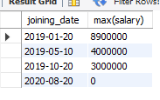
- Find the highest salary of each week of the year on joining_date

select week(Joining_date), max(Salary) from Employee group by week(Joining_date);

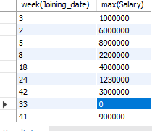

- Find the highest salary on the even days of joining_date

select Joining_date, max(Salary) from Employee
where Joining_date in(select Joining_date from Employee where Joining_date%2 = 0);
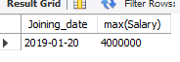
to find all salary on even days:

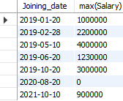
select Joining_date, max(Salary) from Employee
where Joining_date in(select Joining_date from Employee where Joining_date%2 = 0) group by Joining_date;
- Find the highest salary on the odd days of joining_date

select Joining_date, max(Salary) from Employee
where Joining_date in(select Joining_date from Employee where Joining_date%2 <> 0);


-- on all odd days

select Joining_date, max(Salary) from Employee
where Joining_date in(select Joining_date from Employee where Joining_date%2 <> 0)group by Joining_date;
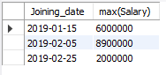

- Find the highest salary of even months on joining_date

select Joining_date,month(Joining_date), max(Salary) from Employee
where month(Joining_date) in (select month(Joining_date) from Employee where month(Joining_date)%2 = 0);

- Find the highest salary of odd weeks of the year on joining_date

select Joining_date,week(Joining_date), max(Salary) from Employee
where week(Joining_date) in (select week(Joining_date) from Employee where week(Joining_date)%2 <> 0);

- Find week of the month for each joining_date

- Find the highest salary for each week of the month on joining_date

